JPC makes every effort to ensure the accuracy of all the information (the “Content”) contained in the publications on our platform. However, JPC make no representations or warranties whatsoever as to the accuracy, completeness, or suitability for any purpose of the Content. Any opinions and views expressed in this publication are the opinions and views of the authors, and are not the views of or endorsed by JPC The accuracy of the Content should not be relied upon and should be independently verified with primary sources of information. JPC shall not be liable for any losses, actions, claims, proceedings, demands, costs, expenses, damages, and other liabilities whatsoever or howsoever caused arising directly or indirectly in connection with, in relation to or arising out of the use of the Content.

This article may be used for research, teaching, and private study purposes. Any substantial or systematic reproduction, redistribution, reselling, loan, sub- licensing, systematic supply, or distribution in any form to anyone is expressly forbidden. Terms & Conditions of access and use can be found at: http://promotionalcommunications.org/index.php/pc/about/submissions

**Journal of Promotional Communications**

Publication details, including instructions for authors and subscription information: http://

**Exploring the Role of Product Involvement in Shaping Impulsive Buying Tendencies in Online Retail Environments.**

Nathaniel Lloyd

Published online:

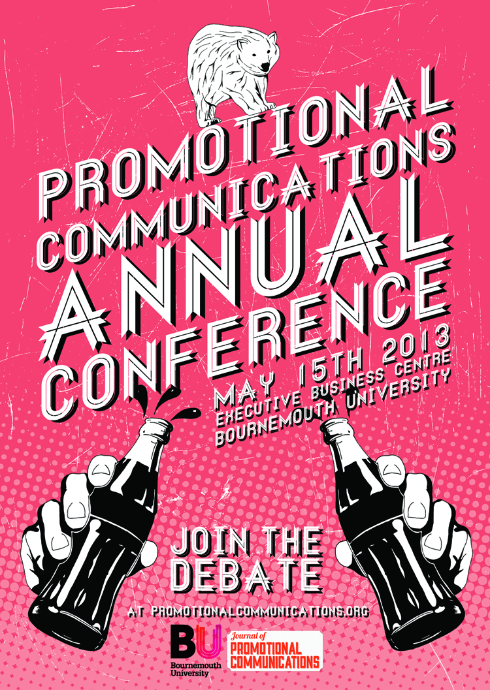

PLEASE SCROLL DOWN FOR ARTICLE

To cite this article: Lloyd, N. 2014. Exploring the Role of Product Involvement in Shaping Impulsive Buying Tendencies in Online Retail Environments, *Journal of Promotional Communications*, 2 (1): 87- 112

**Nathaniel Lloyd**

**Exploring the Role of Product Involvement in Shaping Impulsive Buying Tendencies in Online Retail Environments**

*While currently viewed as a fixed trait within consumers, research now suggests that impulsivity is best measured as a product specific tendency, mediated by an individual’s involvement with a product category. Despite the recognised proliferation of online impulse buying behaviour, no empirical research has yet explored this notion within the context of online retail environments. This study addresses this omission and explores the mediating effect of product involvement on online impulse buying tendency within two product categories, music and clothing, as well assessing the extent to which product specific impulsiveness may affect the manner in which consumers interact with websites. Findings indicate that impulse buying tendency does vary according to product category in online consumers, and that this variance can alter the website characteristics consumers focus on when browsing. The theoretical and managerial implications of these findings are discussed and areas for future research addressed.*

Keywords: Online behavior, impulsive buying behavior, involvement, e-commerce marketing stimuli

INTRODUCTION

Lloyd, N. 2014. Exploring the Role of Product Involvement in Shaping Impulsive Buying Tendencies in Online Retail Environments, *Journal of Promotional Communications*, 2 (1): 87-112



While it is easy to overlook the importance of impulse buying by confining the behaviour to last minute purchases of sweets or magazines at the checkout, research has shown impulsively bought items to equate to anywhere from 40-80% of all purchases (Hausman 2000) and to span a broad range of products and services (Rook and Fisher 1995). With authors long recognising the considerable contributions impulsively bought items make to a business’s overall sales (Clover 1950; Applebaum 1951), it is imperative businesses and marketers have a solid understanding of the mental processes and marketing triggers that comprise this behaviour to more effectively manage and encourage impulsive purchases as a valuable revenue source.

Interest in the concept and attempts to understand the precursors of impulsive behaviour has long been a subject of debate, with seminal author Rook (1987) even citing the biblical story of Adam, Eve and the apple as the first case of an ‘impulse buy’. More recently, there has been a cannon of research developed since the 1950’s exploring impulse buying behaviour (IBB) in the context of traditional bricks and motor stores, with notable work in the 1980s and 90s advancing the understanding of the cognitive processes required for a true impulse buy, and developing the definitions still widely cited today. Despite this proliferation of literature, research continues to emerge that highlights previously untested concepts, recently that of product involvement, as important mediating factors in the impulse buying process (Jones et al. 2003). Initial studies have shown product involvement to increase the chance of individuals impulse buying in particular product categories; however this research has so far been limited to traditional retail stores. Advancement of this understanding would allow for the development of more effective digital retail environments which would encourage and stimulate these key impulsive consumers.

While literature-exploring IBB in traditional retail environments is abundant, focus on digital retail remains limited in comparison, despite the recognition of the digital medium as a catalyst for impulsive purchasing (Donthu and Garcia 1999). Even before the internet, authors noted that characteristics of TV shopping (easy access, immediacy of purchase, credit card payments) which are now synonymous with online shopping, were seen to increase consumer’s ability and propensity to engage in impulse buying (Rook 1987). The increased convenience and anonymity of shopping online compounds this (Chih et al. 2012) and an estimated one quarter to four fifths of online consumers engage in impulse buying (LaRose and Eastin 2002). While authors are now attempting to investigate the extent to which findings from bricks and motor studies are relevant online (Floh and Madlberger 2013), findings suggest that in some traditionally high-impulse industries such as groceries, the different atmospheric and marketer controlled cues present during online shopping mean that consumers are actually less impulsive (Kacen 2003). This lack of solid understanding is reflected in business practise, with Huang (2003) demonstrating the lack of consistency and innovation in current corporate websites. This paper aims to fill this gap in the current literature by exploring more thoroughly the influence of product involvement in online impulse buying episodes, and how this affects the manner in which consumers interact with digital environments, providing insight useful both to marketing academics and practitioners.

The importance of understanding online shopping habits becomes apparent when the size and growth of the online retail market is examined. Ofcom (2011) reports the UK as being one of the most prolific nations for internet use, with 89% of consumers visiting a retail site in 2010. Comparable levels of digital traffic have also been reported in Government statistics. Figure 1 shows the growth rates for online access since 2006, with as many as 35.7M (73%) of all UK adults reporting daily internet activity in 2013 and 72% reporting buying goods or services online (+53% since 2008) (Office for National Statistics 2013). In addition to time, online shoppers now report spending twice as much money online as they did 10 years ago, with the knock on effect being that up to a fifth of high street stores could risk closure in the next 4 years (Evans 2013). With this increasing influence from the online environment, and online retail in particular, it becomes ever more important that more research is focused towards understanding consumer behaviour and motivations in this retail channel, to allow better management of the continued migration online.

### Figure 1: Chart showing growing daily online usage in the UK (Office for National Statistics 2013)

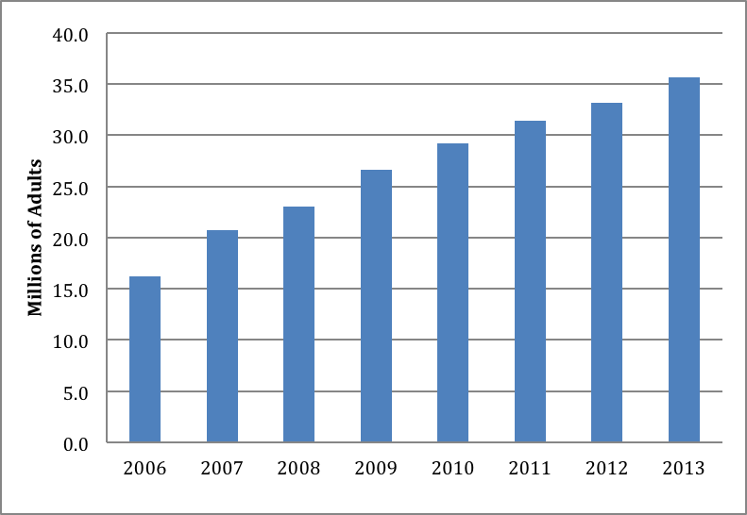

Year

# LITERATURE REVIEW

To help frame and guide the research, the key concept of impulse buying will first be explored and definitions proposed. The external marketing stimuli and internal consumer motivations driving this behaviour will be discussed and a theoretical framework developed for testing.

# Defining Impulse Buying

Early attempts to conceptualise impulse buying behaviour (IBB) include Stern’s (1962) widely cited impulse mix, which delineated four distinct types of impulse purchase (pure, planned, reminder and suggestion) by examining consumer’s shopping intent and the external stimuli influencing consumer impulse. While this important work has helped to frame many subsequent studies (Madhavaram and Lavie 2004), it was consistent with other early literature in that it failed to draw a distinction between ‘unplanned’ and ‘impulsive’ behaviour. The difference in consumer motivation driving these separate concepts has been seen as crucial to the understanding of the buying impulse (Rook 1987). Research now suggests that while IBB is often unplanned, unplanned purchases are not always impulsive (Kollat and Willett 1969; Kacen et al. 2012). Although the lapse in time between desire to purchase and purchasing behaviour is similarly short in both unplanned and impulsive purchases, unplanned purchases can include simple out-of-stock items missed from a structured shopping list (Amos et al. 2014) while the drivers of IBB are psychologically complex and include hedonistic (Činjarević 2011), affective (Piron 1991; Weinberg and Gottwald 1982) and even normative (Rook and Fisher 1995) influences.

Rook and Hoch’s (1985) research directed attention towards the cognitive and emotional elements present in IBB and identified 5 key psychological elements crucial to impulse buying (spontaneous desire to act, psychological disequilibrium, psychological conflict, reduction in cognitive evaluation and a disregard for consequences) that have remained central to the literature. Following this study, Rook (1987), in his seminal paper ‘The Buying Impulse’, suggests impulse buying occurs when:

“A consumer experiences a sudden, often powerful and persistent urge to buy something immediately. The impulse to buy is hedonically complex and may stimulate emotional conflict. Also impulse buying is prone to occur with diminished regard for its consequences.” (Rook 1897, p191)

While this definition has received wide acceptance in its identification of the psychological constructs of impulse purchasing, there have also been criticisms. Piron (1991) argues the definition places too much emphasis on cognitive and emotional reactions by implying that these must accompany IBB. This is also a concern raised by Beatty and Ferrell (1998) who propose the exclusion of simple reminder items, such as the replenishment of grocery products unlikely to generate an emotional reaction, from their definition of IBB. Additionally Rook’s (1987) definition fails to mention the external marketing stimuli which were previously central to IBB research (Applebaum 1951). Madhavaram and Lavie (2004) note these discrepancies and propose the following conceptualisation specifically tailored for online IBB:

“Impulse buying is a result of a purchaser’s immediate reaction to external stimuli that is often hedonically charged. An impulse buying episode signifies a change in purchaser’s intention to purchase that particular product before and after the exposure to stimuli. The stimuli are not limited to just the product and the change in purchaser’s intention does not include a reminder item that is simply out of stock at home.” (Madhavaram and Lavie 2004, p60)

By considering both the situational and dispositional variables (Beatty and Ferrell 1998) of impulse purchasing, this definition is better suited for framing research exploring online consumer behaviour which has tended to examine the impact of various external online stimuli on consumer’s internal considerations (Dawson and Kim 2009; Wells et al. 2011; Floh and Madlberger 2013), and will therefore be adopted to help frame the design of this study.

Impulse Buying Tendency

A concept explored in the literature as the most significant mediator of consumer IBB is that of impulse buying tendency (IBT), defined by Rook and Fisher (1995) as a consumer’s propensity “to buy spontaneously, unreflectively, immediately and kinetically” (Rook and Fisher 1995, p306). IBT is a behavioural trait often characterised as a lack of self-control in the face of conflicting goals, for example between saving money and the immediacy of feeling good post-purchase (Baumeister 2002). Research exploring this area indicates that the likelihood of a consumer engaging in IBB is closely linked with their IBT (Rook and Fisher 1995; Beatty and Ferrell 1998; Sharma et al. 2010).

Rook (1987) identified that consumers vary in their impulse buying proclivities, paving the way for subsequent research to begin developing systems of IBT measurement. The widely cited Impulse Buying Tendency Scale was first developed by Rook and Fisher (1995), designed to measure the impulsiveness trait as it pertains to the purchase and use of products (Amos 2014). Additional measures have since been developed by Puri (1996), Beatty and Ferrell (1998) and Verplanken and Herabadi (2001). All of these measures seek to identify IBT by looking at the psychological constructs proposed by Rook and Hock (1985), using retrospective self-reporting methods to establish the trait (Verplanken and Herabadi 2001).

Internal Stimuli

The establishment in the literature of an impulse buying trait suggests the existence of a chronic disposition towards impulse buying. This is supported by the idea of impulse buying as a lack of will or ‘immaturity’ on the part of the consumer (Rook and Fisher 1995) and associations to Freudian notions of the suppression of the reality principle in favour of the pleasure principle (Freud 1951). As literature on the subject has developed, additional internal motivations alongside IBT have been identified, such as normative evaluations (Chih et al. 2012), hedonic desire (Childers et al. 2001) and product involvement (Jones et al. 2003), which also play a part in the impulse buying process and suggest a greater degree of variance in customer IBT than previously assumed.

Normative Assessment

Rook and Fisher (1995) first suggested that despite IBB’s associations with ‘selfish’ wish fulfillment, there are many times when the behaviour can incur only minor infractions from social norms or even be normatively positive. The authors found that normative evaluation takes the place of the subjective norm proposed in the traditional theory of reasoned action (Ajzen and Fishbein 1980), with consumers able to tell the difference between, for example, impulsively spending $50 of lottery winnings and the same amount of rent money. Despite this, Sharma et al. (2010) found self-monitoring was negatively associated with impulse buying, suggesting that while consumers are able to apply normative assessment to impulsive purchases; it is not conducive to the behaviou

Hedonic Motivations

Consumer mood has also been widely explored as a mediator of impulse purchasing (Gardner and Rook, 1988; Flight et al. 2012), with Rook (1987) describing an impulse buy as “extraordinary and exciting” (p191) and further research by Weinberg and Gottwald (1982), Rook and Gardner (1993) and Piron (1993) exploring the heightened emotion that accompanies an impulse purchase. Despite previously mentioned negative connotations related to impulse buying, most studies have found consumer mood to be positive post-impulse purchase, with only 20% of respondents in Rook’s (1987) study reporting feeling ‘bad’ about their impulsive behaviour. Hausman (2000) explains that impulsive purchases satisfy hedonic, as well as utilitarian, consumer desires, with shoppers engaging in ‘retail therapy’ as a social pleasure.

Hedonic motivations are particularly important when exploring online IBB; as Childers et al. (2001) note, online retailers are able to create a “cognitively and aesthetically rich shopping environment in ways not readily imitable in the nonelectronic world” (p511). This emersion in the retail environment was conceptualised in Beatty and Ferrell’s (1998) original model of impulse buying as *shopping enjoyment* and *in-store browsing,* with the authors finding that encouragement of these factors would increase a customer’s propensity to engage in IBB. The idea has been adapted for online behaviour through the idea of flow theory (Koufaris 2002), where compelling navigation can lead to stronger consumer engagement with the website. Park et al. (2012) describes this as hedonic web browsing and their findings show a strong positive association between hedonic browsing and impulse buying, while utilitarian browsing was shown to decrease impulse purchases.

Product Involvement

Involvement is defined as “a person’s perceived relevance of the object based on inherent needs, values and interests” (Zaichkowsky 1995, p342). While the influence of product involvement on IBT has received limited attention in the literature, Jones et al. (2003) note the similarities between these constructs, with both defined by enhanced emotional appeal and increased consumer hedonic activity. Block and Bruce (1984) portrayed product involvement as a leisure activity and highlighted the construct as key in understanding recreational shopping behaviour. The hedonic dimension of involvement has been explored by others who found that product involvement will increase a consumer’s hedonic browsing activity within a specific category (Bloch et al. 1989; Schmidt and Spreng 1996), with this also shown by Beatty and Ferrell (1998) and Park et al. (2012) to be an important precursor to IBT. Further studies examining high-involvement categories such as clothing have found that the pleasure derived from hedonic information search and proximity with the product is actually central in creating involvement within consumers (Michaelidou and Dibb 2006).

Jones et al. (2003) found that by measuring levels of involvement alongside IBT using McQuarrie and Munson’s (1992) Revised Product Involvement Inventory, they were able to better predict consumer behaviour in specific product categories, which they describe as *product specific IBT*. While this initial research into the relationships between involvement and impulsive behaviour has yet to be further explored, studies by Floh and Madlberger (2013) and Koufaris (2002) have highlighted the need for further research to better understand and predict this “situational impulsiveness” (Floh and Madlberger 2013, p433), especially in online environments where hedonic browsing is prevalent.

External Stimuli

External stimuli consist of the atmospheric, marketer controlled and marketing mix cues that can trigger an impulse in consumers (Young and Faber 2000). Amos’s (2014) meta-analysis of impulse buying literature shows that it is the combination of high IBT and specific retail situations created by these external stimuli that produce the most instances of IBB, although further research is needed to develop the body of literature exploring these stimuli in the online environment. Initially, external stimuli were limited to the product and related variables such as in-store product positioning and merchandising (Applebaum 1951; Cox 1964) but have since been expanded under the umbrella term atmospherics (Kotler 1973) to include all aspects of the retail environment as well as cues such as price incentives (Dawson and Kim 2009) and, in online retail environments, aspects of usability such as navigation (Floh and Madlberger 2013) or website security (Bart et al. 2005).

**Webmospherics**

Childers et al. (2001) propose the term *webmospherics* to apply to the virtual surroundings in online retail environments. While lacking in some of the key sensory stimuli that physical proximity to goods can provide, such as touch (Peck and Childers 2006), Donthu and Garcia (1999) found internet shoppers to be more impulsive due to the wide range of digital stimuli they are exposed to. A recent study by Floh and Madlberger (2012) supports this assertion through further testing that demonstrates the persuasive effect webmospherics have on IBB, and categorises these stimuli into website content, design and navigation. Bressolles et al. (2007) suggest that these factors increase impulse purchases through their ability to satisfy the customer and negate concerns of psychological or financial risk. Risk due to the separation of the buyer and seller and intangibility of the seller’s intentions has been shown to have a major impact in online consumer decision making (Forsythe and Shi 2003) with research by Bart et al. (2005) showing that website characteristics such as privacy and security notices and even simply an absence of errors are key in the development of online trust which encourages purchasing. In addition to trust building, Verhagen and Dolen (2011) demonstrate how the functional convenience of a website is positively linked to shopping enjoyment, previously discussed in relation to hedonic desires as a central mediator to online impulse buying. It has long been recognised that greater exposure to a stimuli leads to increased impulse buying episodes (Iyer 1989; Kollat and Willett 1969), so factors that encourage greater engagement with a website should be examined for their effect on IBT. Floh and Madlberger (2013) also note he importance of online browsing and highlights the influence of product involvement as a factor encouraging website engagement.

Theoretical Framework

As the extant literature has shown, an understanding of the interaction between marketer controlled stimuli and consumer’s impulsive proclivities is central to research exploring impulse buying. However, these are complex and multi-faceted concepts and the literature is far from agreed on specific definitions of the behaviour, especially in the context of online IBB (Madhavaram and Lavie 2004) where research is underdeveloped and requires further study. While introduced and accepted as a single, stable construct in early seminal works by Rook (1987), Rook and Fisher (1995) and Beatty and Ferrell (1998), the findings of Jones et al. (2003) suggests IBT is not consistent, but instead mediated by product involvement and therefore variable over different product categories. The conceptual model developed for this research (Figure 2) has therefore been adapted from these findings and considers both general and product specific IBT to explore the effect of product involvement in the context of online retail environments, and identify differences with traditional shopping behaviour. As highlighted by Floh and Madlberger (2013), there currently exists no literature that has examined the relationship between product involvement and online marketing stimuli in the context of IBB, and therefore this will also be considered in the research. An examination of the literature has provided four categories of online stimuli for testing, related either to the product, hedonic browsing activity, website quality or normative evaluations. These will be tested to explore whether their effectiveness grows or lessens with product involvement, a previously unexplored notion which will help to develop not only understanding of online marketing stimuli but also the nature of IBT as a product specific variable.

# 

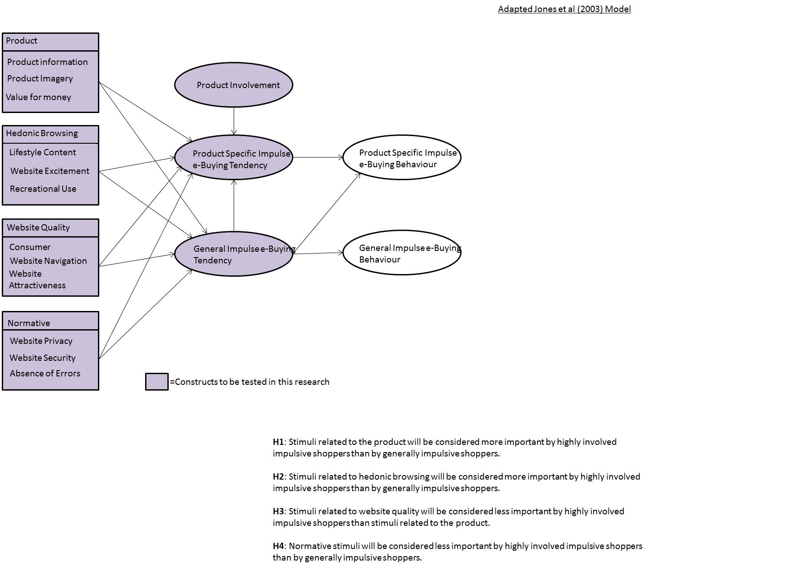

**Figure 2: Conceptual Model (Adapted from Jones et al. (2003))**

# METHODS

This section will discuss the development and implementation of the research process used in this study, reviewing its validity and examining potential limitation

Research Aim

To explore the effectiveness of digital marketing stimuli in relation to online impulse buying tendencies, and to consider the effect product involvement has in mediating this relationship.

Hypothesis

**H₁**: Respondents will exhibit differences between reported general IBT and product specific IBT.

**H₂**: Increased product involvement will result in higher levels of product specific IBT within that category.

**H₃**: Online stimuli related to the product will be considered more important by product specific impulsive shoppers than by generally impulsive shoppers.

**H₄**: Online stimuli related to hedonic browsing will be considered more important by product specific impulsive shoppers than by generally impulsive shoppers.

**H₅**: Online stimuli related to website quality will be considered less important by product specific impulsive shoppers than stimuli related to hedonic browsing.

**H₆**: Normative stimuli will be considered less important by product specific impulsive shoppers than by generally impulsive shoppers.

Research Philosophy

The research was developed using a positivist epistemology, seeking to test hypotheses drawn from a wider study of the available literature in line with the principles of deductivism (Bryman and Bell 2011). In keeping with this philosophy, the research methods were designed to allow experimentation leading to either validation or falsification of the central constructs highlighted in the conceptual model (Figure 1) (Easterby-Smith et al, 2008).

Data Collection

In line with much of the extant literature, data collection was conducted using a self-administered, anonymous, online survey. Distribution through an online medium allowed direct access to internet users, in addition to providing greater control of data collection and reduction in the likelihood of contamination (Saunders et al. 2009). In order to more stringently test the hypothesis, data was collected across two product categories simultaneously; digital music (mp3 downloads) and clothing procured through digital channels (Jones et al. 2003). These categories were chosen due to their high involvement nature (Michaelidou and Dibb 2006; Jones et al. 2003), as well as being among the most widely purchased products online. Differences between the product categories were also examined, adding further depth to the analysis.

The survey was live for two weeks from the 26th March to the 9th April 2014. Prior to this a pilot study was administered to five respondents to assess content validity and clarity of questioning (Saunders et al. 2009). Drawing on this feedback, minor alterations were implemented which improved the layout of the questionnaire and resulted in a rewording of Question 3. The survey comprised of three sections (S). S1 collected basic demographic data of respondents, as well as assessing online purchasing habits and general IBT. S2 collected data relevant to the digital music category, testing product involvement, product specific IBT and assessment of stimuli. S3 repeated these tests, with focus on the clothing category.

Scale Development

All items included in the survey were taken from established scales, with some adapted to the specific context of this research. IBT and product specific IBT were measured using Park et al.’s (2012) adaptation of Rook and Fisher’s (1995) Impulse Buying Tendency Scale, which has been simplified and modified to better test online behaviour. To measure product specific IBT the items were adapted to apply to the two product categories, as recommended by Jones et al. (2003), and participants instructed to consider their responses in the context of either digital music or online clothing consumption. Product involvement was measured using McQuarrie and Munson’s (1992) Revised Product Involvement Inventory. This adaptation has been successfully applied in a similar context by Jones et al. (2003) and has been shown to have comparable levels of reliability and validity to Zaichkowsky’s (1995) widely cited Product Involvement Inventory. The measures relating to online external stimuli have been chosen after a review of the relevant literature, from items originally proposed by Floh and Madlberger (2013), Park et al. (2012), Verhagen and Dolen (2011) and Bart et al. (2005), with phrasing adapted to better suit the specific aims of this research.

**Sample**

Recent meta-analysis of research into impulse buying has highlighted consistent negative correlations between age and IBB (Amos 2014), suggesting a younger demographic would provide a suitable population for this research. Supporting this, government statistics indicate online purchasing in general is steady across genders (70-74% penetration) but also decreases with age, with between 86-92% of 18-34 year olds participating, eventually falling to 36% for those aged 65< (Office for National Statistics 2013). This age bracket is also shown to have the greatest propensity to purchase clothing (62-68%) and music (46-52%) online compared to other demographics (Office for National Statistics 2013). Mafe and Navarre (2010) have profiled this demographic, described as ‘New Age Techno Lovers’, in relation to online behaviour, noting prolific online use and purchase intent . It is therefore from the population of 18-34 year old online consumers that this study has drawn its sample. A truly representative sample was difficult to extract from this population, due to the scale and demographic complexity of general online use. In light of this, non-probability convenience sampling was utilised to allow a timely return of data, however distribution methods have been chosen to ensure a reasonable level of comparability to minimise sample error (Bryman and Bell 2011). Three online forums were chosen to distribute the survey, with this method of distribution shown to provide a good cross section of online populations for analysis (Lilleker et al. 2013). Two (cosmopolitan.co.uk and menshealth.co.uk) are owned by Hearst Magazines and represent a cross-section of online shoppers, both male and female. In addition, thestudentroom.co.uk was also selected as a suitable forum to reach the ‘New Age Techno Lovers’ population and increase response rates.

Research Quality and Limitations

Multi-item measures have been used to provide a higher degree of reliability in the reporting of data (Gliem and Gliem 2003). A minimum of three items were specified for each scale and composite measures were achieved by summation and averaging of the scale items using the syntaxes described in Appendix 4. As recommended by Churchill (1979), Cronbach’s α was first used to test internal consistency and prove measure reliability. As shown in Table 1, all measures scored above the accepted 0.7 (Nunnally 1978) except for construct HBSM which scored 0.69. While this is not ideal, Hair et al. (2010) describe scores between 0.6 and 0.7 as still acceptable, although clearly indicating lower reliability. For a full descriptive list of items used in this research see Appendix 5.

Pilot testing is a crucial step for self-completion surveys (Bryman and Bell 2011), helping to ensure research validity and clarity. Only minor issues regarding survey layout and wording were flagged as potentially damaging to the research, and were amended prior to publishing the final survey. Practical limitations placed on the accurate representation of sampling methods meant generalisation of findings and analysis was limited. With an estimated population size of 35M (Office for National Statistics 2013), the final sample of 117 gave a confidence interval of 9.06% at a confidence level of 95%. While this is above the typically accepted 5% error margin (Gill and Johnson 2010), this is a common issue with large populations. To address this, scales previously established and tested on wider populations were employed to mitigate issues with instrument reliability and validity (Bryman and Bell 2011) and to provide a greater level of generalisation to the resulting data.

**Table 1: Construct Variable Descriptive Statistics**



# 

# FINDINGS AND ANALYSIS

# Final Sample

In total, 161 responses were collated, of which 43 were excluded due to partial data records. A further response was excluded due to insufficient online shopping participation, leaving a final sample of 117 responses, at a response rate of 73%. The sample slightly favoured females (58%) with the majority of respondents falling between the ages of 21-27 (70%). Reflecting this young demographic, over half of respondents reported an income of <£10,000 (59%) with only 10% reporting earnings >£30,000. Full respondent profile can be viewed in Table 2.



### Table 2: Respondent Profile

# Hypothesis Testing

As a social survey, the analysis of data for this study required a correlational design to examine bivariate and multivariate relationships (Bryman and Craymer 2005). To successfully test the hypothesis a range of statistical analysis tools, in addition to the examination of descriptive statistics, were utilised. Pearson’s bivariate correlation analysis was performed on all measurement variables to assess relationship strength between model constructs (Figure 4) which formed the basis of analysis for H₂-₆. Parametric correlation was selected to describe the relationships as the use of averaged multi-item likert scales increased the possible value range, allowing data to be treated as continuous (Saunders et al. 2009). Non parametric Spearman’s correlation was also used to test ordinal data from individual items. To develop this relational analysis, linear regression was used to predict the behaviour of dependant variables in H₂ and H₆, with a focus on testing the causational relationship postulated in H₂.

Data Screening

Before attempting parametric testing, data screening was conducted to ensure the required assumptions of normality, linearity and homoscedasticity were satisfied (Field 2013). Examination of descriptive histograms indicated non-normally distributed data on all construct variables except GIBT and MINV. This was confirmed via the Shapiro-Wilk test (Shapiro and Wilk 1965) which showed data to be not normally distributed (*p*<0.05). Due to the use of Likert scale data this was expected and using Norman’s (2010) arguments of data robustness, parametric analysis was still deemed appropriate. Tests of linearity and homoscedasticity for constructs included in regression analysis were undertaken via a zpred vs. zresid plot of model residuals (Field 2013), with results indicating both assumptions were met and allowing for the continuation of analysis.

Testing Variable Impulse Buying Tendency

To initially determine the extent to which IBT varies across product categories in online consumers, a comparison of the mean scores for GIBT, MIBT and CIBT was undertaken. This examination highlighted differences between constructs, with MIBT shown to be the strongest trait (*M*=4.64, *SD*=1.62) followed by CIBT (*M*=3.91, *SD*=1.49) and finally GIBT (*M*=3.81, *SD*=1.38). These results show that within the sample, consumers were more impulsive when shopping online for music than clothing, and more impulsive when shopping online for clothing than shopping in general. Mean scores were then segmented by the four demographic criteria to test variance across age, gender, income and online shopping proclivity (See Figure 3). On only two occasions were identical scores found; between GIBT and MIBT within the ‘£30,000-39,000’ income bracket and within the ‘Less Than Once a Month’ bracket measuring online purchasing habits. All other demographic segmentations reported differing scores across all IBT measures.

In addition to overall means testing, results were filtered to identify individual cases where IBT was reported as equal across general and product specific categories. Findings reported no instances of individuals scoring the same across all three variables, and highlighted only 5 cases (4%) reporting the same score for MIBT and GIBT as well as CIBT and MIBT, and only 13 (11%) reporting the same score for CIBT and GIBT. From this analysis, it can be concluded that variance does exist across general and product specific IBT in online consumers, confirming H₁. The greater differences discovered between CIBT and MIBT validated the need for further investigation to understand the mediating effect of product involvement.

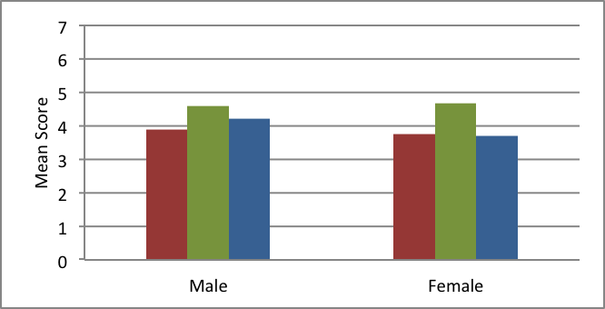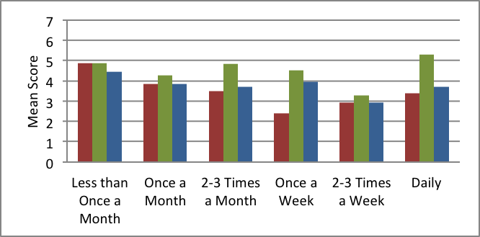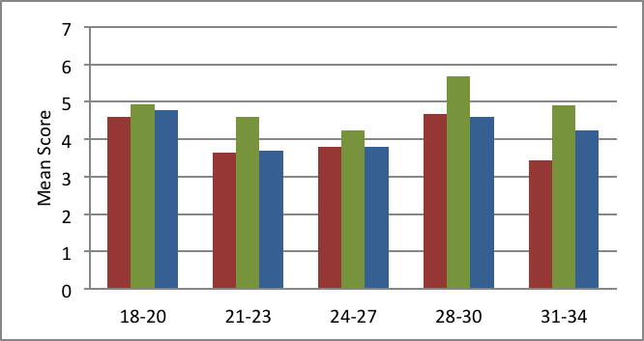

### Figure 3: Impulse Buying Tendency Means Comparison

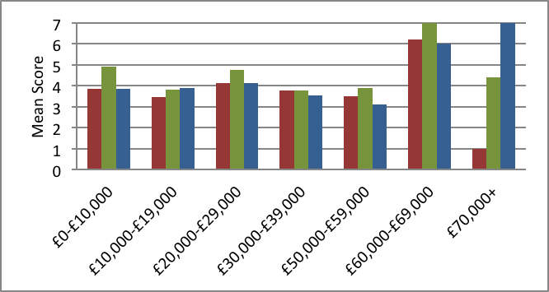

GIBT

MIBT

CIBT

**Gender**

**Age**

**Income**

**Online Purchasing**

## Figure 4: Model Correlations

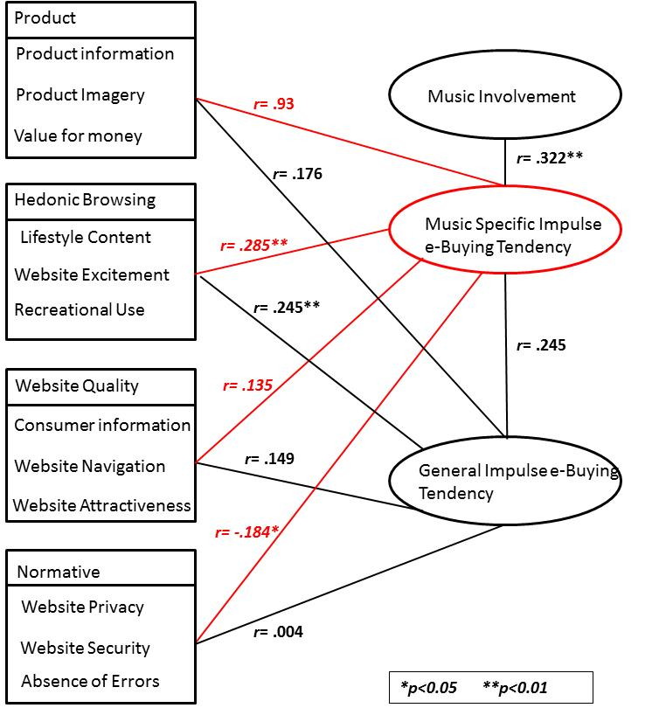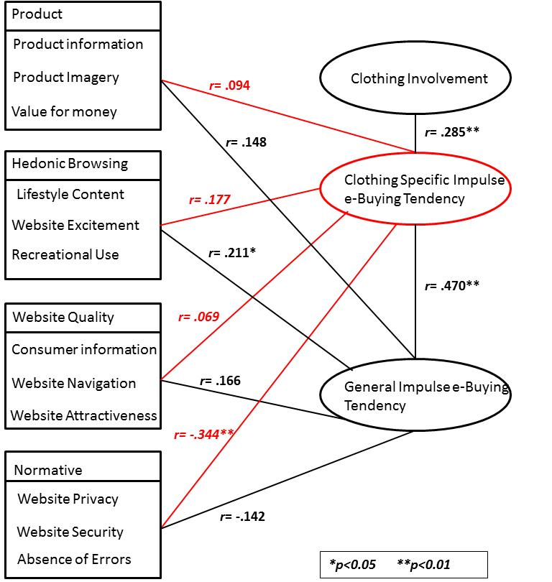

Music Category

Clothing Category

# Testing the Mediating Effect of Product Involvement

Once varying levels of IBT had been established, further analysis could take place to investigate the extent to which product involvement acts as a mediator, influencing the variance in IBT during online impulse purchasing decisions. For each of the product categories, the relationships between product involvement and product specific IBT were investigated and compared to GIBT. Pearson’s *r* results (Figure 4) indicated significant (*p*<.01) positive correlations between product involvement and product specific IBT in both the music category (*r(117)=*.322) as well as the clothing category (*r(117)=*.285). Additionally, both categories indicated stronger positive relationships between involvement and product specific IBT than GIBT, suggesting product involvement exerts a greater influence in the formation of product specific IBT than general IBT.

Following these initial positive results, linear regression was used to expand on the analysis and to predict the behaviour of product specific IBT when product involvement was manipulated. Simple regression analysis revealed product involvement could be used to predict MIBT (*r²* =.104 (adjusted *r²*=.096), *F*(1,115)=4.2, *p*=.42) and to a lesser extent CIBT(*r²* =.081(adjusted *r²*=.073), *F*(1,115)=10.14, *p*=.002). Examination of the unstandardized $β$ indicated that for every unit increase in product involvement, CIBT would rise .358 and MIBT would rise .493. The regression equations for each test can be viewed alongside the graph visualisations in Figure 5. In combination with the Pearson correlation results, this testing confirmed H₂ by showing an increase in product involvement can account, at least partially, for an increase in product specific IBT.

Measuring Stimuli Impact

To fully address the research aim, this analysis sought not only to test the role of product involvement in effecting online IBT, but also to consider how this variance could affect consumer responses to external marketing stimuli found online. Initial observation noted that across both product categories, stimuli related to hedonic browsing were rated most highly (HBSM: *M*=3.27, *SD*=1.150, HBSC: *M*=3.19, *SD*=1.28). Within the music category, normative stimuli received the lowest score (*M*=2.70, *SD*=1.25) while within the clothing category, website quality was considered least important (*M*=2.30, *SD*=0.91). Full descriptive statistics of the stimuli measures can be seen in Table 1. Responses were also filtered individually to compare scores across product categories. For the majority of cases, respondents rated stimuli at differing levels of importance across the two categories, indicating a preference for different stimuli when considering different products. Cases of respondents rating stimuli as equally important across product categories were highest in normative stimuli (*N*=26, 22%), followed by hedonic browsing (*N*=25, 21%), website quality (*N*=13, 11%) and product (*N*=8, 7%). Non-parametric Spearman’s correlation tests were used to examine the relationships between GIBT, MIBT and CIBT and the individual

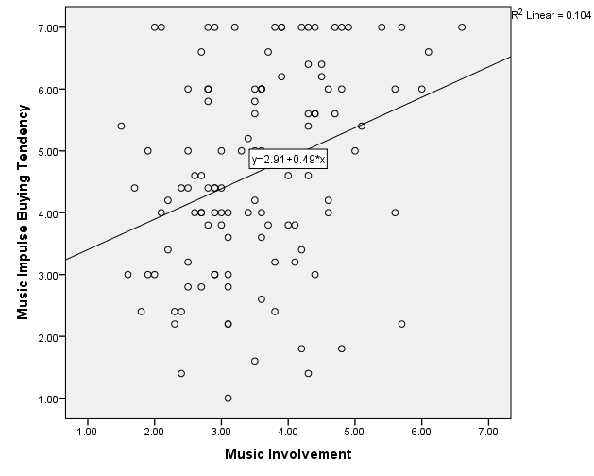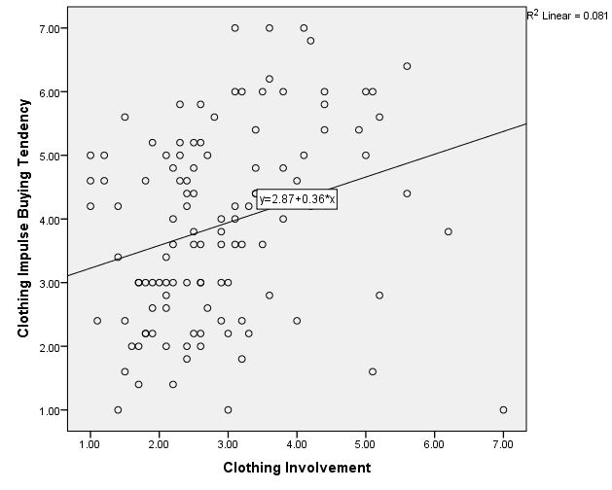

### Figure 5: H₂ Regression Plots

stimuli items used in the survey. While hedonic browsing stimuli was shown to be most highly rated as a composite variable, when examined individually the visual aesthetics of a clothing website was found to have the strongest relationship with CIBT (*r(117)=*.227, *p*=.014), while GIBT was shown to most strongly correlate with easy website navigation in the clothing category (*r(117)=*.282, *p*= .002). Within the music category, the item correlations more closely matched those of the composite variables, with both MIBT (*r(117)=*.306, *p*=.001) and GIBT (*r(117)=*.285, *p*=.002) exhibiting the greatest correlation with being able to browse ‘just for fun’ when shopping for music.

To investigate this further and to test H₃-₆, the Pearson correlation scores (Figure 4) were compared in relation to general and product specific IBT. While it was hypothesised product specificity would increase the importance rating of product related stimuli over generally impulsive consumers, this was not found to be the case in either category. Although not statistically significant (*p*>0.05), in both music (*r(117)=*.176) and clothing (*r(117) =*.148), GIBT was found to have a stronger relationship to product related stimuli, rejecting H₃. Next, the results pertaining to hedonic browsing were examined. Within the music category the relationship with MIBT (*r(117)=*.285, *p*<.001) was stronger than GIBT (*r(117)=*.245, *p*<.001), however within the clothing category, CIBT (*r(117)=*.177, *p*=.057) was found to have a weaker relationship than GIBT (*r(117)=*.211, p<.05). Despite this, in both categories hedonic browsing was considered more important by product specific impulsive shoppers than website quality, which displayed low levels of correlation within the music category (*r(117)=*.135, p=.147) and especially the clothing category (*r(117)=*.069, p=.459). Through the comparisons of these scores, H₅ was accepted and H₄ was accepted within the music category but rejected within the clothing category. Finally, analysis showed normative stimuli to be the only category with negative correlations to both product specific IBTs. When compared to GIBT it was found that in both cases product specificity reduced the likelihood of rating normative stimuli more important, with CIBT (*r(117)=* -.344, *p*<.001) found to have a greater negative correlation than MIBT (*r(117)=* -.184, *p*=.047). While these results confirmed H₆, regression analysis was then conducted to further explore these negative correlations. With product specific IBT as the independent variable, it was found that ratings of normative assessment fell as product specific IBT grew in both the music category (*r²* =.034 (adjusted *r²*=.025), *F*(1,115)=4.02, *p*=.47) and more strongly in the clothing category (*r²*=.118 (adjusted *r²*=.111), *F*(1,115)=15.44, *p*<.001) (see Figure 6). This means ratings of importance for normative stimuli were shown to fall the greater the score for MIBT or CIBT. To summarise the results of the hypothesis testing, H₁, ₂, ₅ and ₆ were accepted in both the music and clothing categories. H₄ was accepted in the music category but rejected in the music category and H₃ was rejected across both categories.

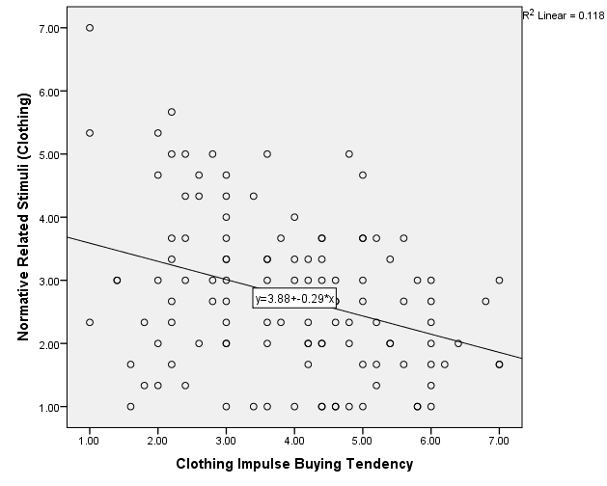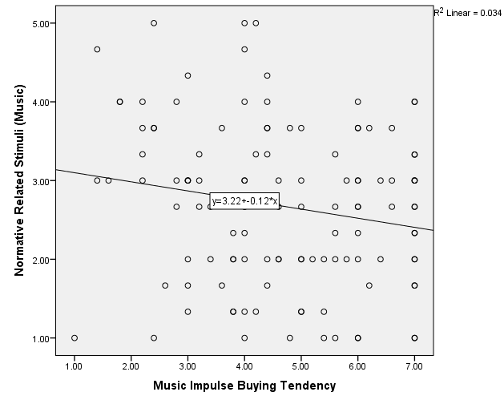

### Figure 6: H₆ Regression Plots

# DISCUSSION

The findings of the research will now be summarised and discussed. The analysis will be interpreted in the context of the existing literature to draw out further meaning and understanding from the data. The stated aim of this research can be divided into two distinct parts, which helped to frame the formation of hypothesis and subsequent analysis of data. Firstly, the mediating effect of product involvement in the formation of online IBT needed to be explored as an area previously untested in the literature, and one of significance given the ever growing online market. Once this was established, the four categories of stimuli could be examined in relation to general and product specific IBT scores to identify differences in response. Through this approach, the research was able to successfully develop the findings of Jones et al. (2003) by testing the mediating effect of product involvement in online environments, as well as being the first to consider external marketing stimuli in this testing. This was in line with Madhavaram and Lavie’s (2004) previously discussed definition of impulsive purchasing which requires the inclusion of both external and internal stimuli. Acceptance of H₁ and ₂ shows variance does exist between general and product specific IBT, and that this variance is, in part, accounted for by differing levels of product involvement. While these results were expected, due to the conclusions of Jones et al. (2003), these findings have helped provide a deeper understanding of the emotional states that affect online impulse buying, building on similar research exploring the wider concept of “situational impulsiveness” (Floh and Madlberger 2012, p433).

While the analysis revealed that product involvement accounts for some of the variance in IBT scores, it did not produce regression scores high enough to state that product involvement the only cause. Again this was predicted as within the body of literature there has been recognition of several other key antecedents and mediators of IBT, collated in Beatty and Ferrell’s (1998) original model, such as time and money available, shopping enjoyment and positive and negative affect, among others. Since Rook and Fisher (1995) first developed the concept of impulse buying tendency as an internal, variable and measurable trait, research has been attempting to create more accurate models to predict the behaviour in consumers. The findings from this study help to increase the accuracy of these measurements by adding product involvement to the growing list of mediating variables which must be considered when attempting to predict consumer IBT online.

An unexpected result drawn from this analysis was the finding that clothing was the less impulsive of the categories tested, receiving a lower mean IBT score than the music category. In Jones et al.’s (2003) study, clothing was found to be the more impulsive of the two categories, however the difference in results may relate to the online context in which these variables were tested. Due to online shopping reducing the physical proximity of consumer and product, and therefore immediacy of ownership, impulsiveness may be reduced within this category online, with this happening less so for MP3 music purchases, which are inherently more intangible. This change in impulsivity within a product category when examined online has also been demonstrated for grocery products (Kacen 2003) and highlights the need to examine impulsivity in both traditional and digital retail environments to better test theoretical assumptions and produce more accurate, context-specific models.

An alternative explanation for these results can be drawn from Rook and Fisher’s (1995) study on normative evaluation. Due to the low reported incomes in the sample, normative assessment, relative to social norms, may encourage more deliberation for higher priced clothing purchases, thereby reducing impulsivity more than it would in an affluent sample. While in this study increased CIBT was observed in those indicating higher earnings, more testing is required on a larger sample of affluent online shoppers to validate this claim.

Response to Stimuli

Testing of the stimuli formed the majority of the analysis for this research and provided the most interesting results due to the originality of the data. Findings not only show preferences for different stimuli when rated in the context of different product categories, but also help in to indicate the elements of IBT most affected by product involvement. An initially surprising result was the finding that hedonic browsing was rated as more important within the context of the music category than the clothing category, both as a construct variable and on the item level. As Verhagen and Dolen (2011) demonstrate, shopping or fashion is an inherently hedonic pursuit, a trait also noted by Park et al. (2012), and was therefore predicted to display strong relationships with hedonic stimuli. The explanation for these correlation scores may be found by examining the varying levels of product involvement in each category, which additionally suggest the manner in which product involvement affects IBT.

A common theme found in the literature examining product involvement outside the context of impulse buying, notable that of Block and Bruce (1984) and Michaelidou and Dibb (2006), is the increased desire for hedonic information search in highly involved consumers, with Block and Bruce (1984) claiming this to be central to the construct. An examination of both definitions of impulse buying proposed in this paper show hedonic behaviour to be shown as similarly important to understanding impulsive buying by both Rook (1987) and Madhavaram and Lavie (2004). The findings of the research therefore suggest that it is this hedonic aspect of product involvement that mediates consumer impulsiveness; within the music category where product involvement is high, hedonic stimuli were considered more important than within the clothing category, where product involvement was lower. While it must be stated that correlation does not necessarily equal causation, these findings, coupled with the work of previous studies, point to hedonic tendencies as the aspect of IBT affected by product involvement, and provide insight for future research examining either of these concepts.

In comparison to hedonic browsing stimuli, the two categories tested that were related to more utilitarian shopping habits, website quality and normative stimuli, were shown to have much less correlation with product specific IBT, with normative stimuli shown by regression analysis to actually reduce IBT in both product categories. This result was expected as, due to the work of Rook and Fisher (1995) and other authors such as Činjarević et al. (2011) and Park et al. (2012), it has been shown that shopping with more abandon, for excitement or leisure, is far more conducive for impulsive purchases than consideration of rational or normative factors. These findings add to this understanding by suggesting that product involvement heightens this desire for hedonic shopping within the specific categories, further reducing the relevance placed on utilitarian stimuli.

The most unexpected finding from the analysis was seen in the rejection of H₃, indicating that not only was product related stimuli considered less important in the context of product specific IBT, but also that these stimuli received some of the lowest correlation scores with IBT overall. The hypothesis was set on the basis of work such as Zaichkowsky (1995) who defines product involvement as, “a person’s perceived relevance of the object” (p342), indicating a heightened interest in the product and related stimuli. The findings signifying otherwise may again be related to the online context in which the research was conducted, with the lack of physical proximity of the product meaning consumers focus instead on the surrounding webmospheric stimuli (Childers et al. 2001), which Peck and Childers (2006) suggest is due to the lack of sensory product elements such as touch, smell or simply the allure of immediate possession which can prove so appealing in bricks and motor retail environments.

# CONCLUSION

The purpose of this research was to investigate the influence product involvement has in shaping online impulse buying tendencies, and to consider the effect this may have on the way online marketing stimuli are received and valued by consumers. To do this, the framework proposed by Jones et al. (2003) was adapted to test the relationships between four categories of online stimuli (Product, Hedonic Browsing, Website Quality and Normative) in the context of general or product specific IBT to identify variance which may be explained by the presence of product involvement within two categories; clothing and digital music products. This research was considered justified in the light of the fast growing digital retail sector, and the lack of research to date exploring the effect of product involvement on IBT, especially in online environments.

Findings indicate not only that IBT varies by product category, confirming the validity of Jones et al.’s (2003) theoretical model in the context of online impulse buying episodes, but also that as product involvement, and therefore product specific IBT, varies, so too does the importance consumers place on different marketing stimuli. When considered holistically, the testing of the stimuli revealed the subjective nature by which consumers interact with retail websites, with the product category and related product specific IBT effecting this. Stimuli that encourage browsing were shown to be an important consideration in both product categories for impulsive shoppers, with hedonic stimuli and website navigation producing some of the highest correlation scores. This is supported by the prior observations of Kollat and Willett (1969) and Iyer (1989) who first hypothesised that increasing exposure to stimuli would encourage impulsive tendencies, and subsequent purchases, in consumers.

Conversely, stimuli that offered utilitarian benefits, such as product specifications, or those offering normative reassurance were shown to be considered less important, suggesting that an exciting and hedonically engaging website design is a more effective means by which to encourage impulsive purchases than providing extensive product or technical detail, a finding supported by the work of Childers et al. (2001) and Park et al. (2012). The analysis pertaining to hedonic browsing also offers insight into the nature of the relationship between IBT and product involvement, suggesting that is the shared desire for hedonic experience that creates the positive relationship between the two variables. This brought together the definitions of Madhavaram and Lavie (2004) and Zaichkowsky (1995) to demonstrate the common ground by which these concepts are connected. In addition to contributing to the theoretical body of research, this study is of practical relevance and offers managerial implications for the successful design of websites as well as increasing consumer engagement and frequency of impulse purchase online. The navigation and hedonically appealing aspects of a website should be carefully implemented, not only for the encouragement of impulsive purchases, but also for the purposes of engaging highly involved and therefore valuable consumers.

Due to the convenience nature of the sampling, in combination with the extreme diversity of the population, the results of this study cannot be generalised to include all ‘New Age Techno Lovers’ (Saunders et al. 2009). Additionally, the testing of stimuli was intended to demonstrate a cross-sectional sample of those found online, and to that end should not be considered as an exhaustive list. Indeed, as advances in technology changes the manner by which consumers interact with websites, new stimuli and even new interfaces will require the remodelling of these findings, in much the same way as the digital revolution has warranted this study.

The research also suggests areas for possible future study. Firstly while this paper has examined the mediating variable of product involvement in isolation, a holistic modelling of all known online IBT antecedents would provide a fuller understanding of the behaviour, and update the work of Beatty and Ferrell (1998). Secondly, additional product categories should be examined to provide category specific results for the management of online stimuli.

# REFERENCES

Amos, C., Holmes, G. R. and Keneson, W. C., 2014. A meta-analysis of consumer impulse buying. *Journal of Retailing & Consumer Services*, 21 (2), 86-97.

Applebaum, W., 1951. Studying customer behaviour in retail stores*. The Journal of Marketing*, 16. 172-178.

Ajzen, I., and Fishbein, M., 1980. *Understanding attitudes and predicting social behaviour*. Englewood Cliffs, NJ: Prentice-Halls.

Bart, Y., Shankar, V., Sultan, F. and Urban, G.L., 2005. Are the drivers and role of online trust the same for all web sites and consumers? A large-scale exploratory empirical study. *Journal of Marketing*, 69 (4), 133-152.

Baumeister, R. F., 2002. Yielding to Temptation: Self-Control Failure, Impulsive Purchasing, and Consumer Behavior. *Journal of Consumer Research*, 28 (4), 670-676.

Beatty, S. E. and Ferrell, M. E., 1998. Impulse Buying: Modelling its Precursors. *Journal of Retailing*, 74 (2), 169-191.

Bloch, P.H. and Bruce, G.D., 1984. Product involvement as leisure behaviour. *Advances in Consumer Research*, 11(1), 197-202.

Bloch, P.H., Ridgway, N.M. and Sherrell, D.L., 1989. Extending the concept of shopping: An investigation of browsing activity. *Journal of the Academy of Marketing Science*, 17(1), 12-21.

Bressolles, G., Durrieu, F. and Giraud, M., 2007. The impact of electronic service quality's dimensions on customer satisfaction and buying impulse. *Journal of Customer Behaviour*, 6 (1), 37-56.

Bryman, A. and Bell, E., 2011. *Business Research Methods*. 3rd Ed. Oxford: Oxford University Press.

Bryman, A. and Craymer, D., 2005. *Quantitative Data Analysis with SPSS 12 and 13*. East Sussex: Routledge.

Chih, W., Wu, C.H. and Li, H., 2012. The Antecedents of Consumer Online Buying Impulsiveness on a Travel Website: Individual Internal Factor Perspectives. *Journal of Travel & Tourism Marketing*. 29, 430-443.

Childers, T. L., Carr, C. L., Peck, J. and Carson, S., 2001. Hedonic and utilitarian motivations for online retail shopping behavior. *Journal of Retailing*, 77 (4), 511.

Churchill Jr, G.A., 1979. A Paradigm for Developing Better Measures of Marketing Constructs. *Journal of Marketing Research*, 16(1), 64-73.

Clover, V. T., 1950. Relative importance of impulse-buying in retail stores. *Journal of Marketing*,15 (1), 66-70.

Činjarević, M., Tatić, K. and Petrić, S. a., 2011. See it, like it, buy it! Hedonic shopping motivations and impulse buying. *Economic Review: Journal of Economics & Business*, 9, 3-15.

Cox, K., 1964. The responsiveness of food sales to shelf space changes in supermarkets. *Journal of Marketing Research*, 1, 63-67.

Dawson, S. and Kim, M., 2009. External and internal trigger cues of impulse buying online. *Direct Marketing*, 3 (1), 20-34.

Donthu, N. and Garcia, A., 1999. The Internet Shopper. *Journal of Advertising Research*, 39 (3), 52-58.

Easterby-Smith, M., Thorpe, R. and Jackson, P.R., 2008. *Management Research*. 3rd Ed. London: Sage Publications.

Evans, T., 2013. Online shoppers spending twice what they did 10 years ago as report warns a fifth of UK shops could go in ‘High Street Armageddon’. *This is Money [online].* 28/05/2013. Available from: http://www.thisismoney.co.uk/money/news/article-2332104/Online-shoppers-spending-twice-did-10-years-ago-report-warns-fifth-UK-shops-go.html [Accessed: 11/04/2014]

Flight, R., Rountree, M. and Beatty, S., 2012. Feeling the urge: Affect in impulsive and compulsive buying. *Journal of Marketing Theory and Practice*, 20 (4), 453-465.

Floh, A. and Madlberger, M., 2013. The role of atmospheric cues in online impulse-buying behavior. *Electronic Commerce Research and Applications*, 12 (6), 425-439.

Field, A., 2013. *Discovering Statistics Using IBM SPSS Statistics*. 3rd Ed. London: Sage Publications.

Forsythe, S.M and Shi, B., 2003. Consumer patronage and risk perceptions in internet shopping. *Journal of Business Research*, 56 (11), 867-875.

Freud, S., 1951. Formulations regarding the two principles in mental functioning. *Organisation and pathology of thought: Selected Sources pp.315-328*. New York: Columbia University Press.

Gardner, M. P. and Rook, D. W., 1988. Effects of Impulse Purchases on Consumers' Affective States. *Advances in Consumer Research*, 15 (1), 127-130.

Gill, J. and Johnson, P., 2010. *Research Methods for Managers*. 4th ed. London: Sage Publications.

Gliem, J.A. and Gliem, R.R., 2003. Calculating, interpreting, and Reporting Cronbach’s Alpha Reliability Coefficient for Likert-Type Scales. *Midwest Research to Practice Conference in Adult, Continuing, and Community Education*, 82-88.

Hair, J.F., Black, W.C., Babin, B,J. and Anderson, R.E., 2010. *Multivariate Data Analysis: A Global Perspective*. 7th Ed. London: Prentice Hall.

Hausman, A., 2000. A multi-method investigation of consumer motivations in impulse buying behavior. *Journal of Consumer Marketing*, 17 (4/5), 403.

Huang, A.H., 2003. An empirical study of corporate web site usability. *Human Systems Management*, 22(1), 23-37.

Iyer, E.S., 1989. Unplanned purchasing: knowledge of shopping environment and time pressure. *Journal of Retailing*. 65 (1), 40-57.

Jones, M. A., Reynolds, K. E., Weun, S. and Beatty, S. E., 2003. The product-specific nature of impulse buying tendency. *Journal of Business Research*, 56 (7), 505-511.

Kacen, J.J., 2003. Bricks and clicks and the buying impulse: An investigation of consumer impulse buying behaviour in an online and a traditional retail environment. *European Advances in Consumer Research*. 6, 271-276.

Kacen, J. J., Hess, J. D. and Walker, D., 2012. Spontaneous selection: The influence of product and retailing factors on consumer impulse purchases. *Journal of Retailing and Consumer Services*, 19 (6), 578-588.

Kollat, D. T. and Willett, R. P., 1969. Is Impulse Purchasing Really a Useful Concept for Marketing Decisions? *Journal of Marketing*, 33 (1), 79-83.

Kotler, P., 1973. Atmospherics as a Marketing Tool. *Journal of Retailing*, 49 (4), 48.

Koufaris, M., 2002. Applying the Technology Acceptance Model and Flow Theory to Online Consumer Behavior. *Information Systems Research*, 13 (2), 205-223.

LaRose, R. and Eastin, M.S., 2002. Is online buying out of control? Electronic commerce and consumer self-regulation. *Journal of Broadcasting and Electronic Media*, 46(4), 549-564.

Lilleker, D., Koc-Michalska, K., and Surowiec, P. (2013) Participation in media not across the media: the politically engaged and the usage of the web for political participation. *In A. Charles (Ed.) Media/democracy: a comparative study*. Cambridge: Cambridge Scholars Publishing.

Madhavaram, S. R. and Laverie, D. A., 2004. Exploring Impulse Purchasing on the Internet. *Advances in Consumer Research*, 31 (1), 59-66.

Mafe, C. and Navarre, C.L., 2010. Segmenting consumers by e-shopping behaviour and online purchase intention. *Journal of Internet Business.* 3, 1-24.

McQuarrie, E.F. and Munson, J.M., 1992. A revised product involvement inventory: improved usability and validity. *Advances in Consumer research*. 19, 108-115.

Michaelidou, N. and Dibb, S., 2006. Product Involvement: An Application in Clothing. *Journal of Consumer Behaviour*. 5(5), 442-453.

Norman, G. 2010. Likert scales, levels of measurement and the “laws” of statistics. *Advances in Health Sciences Education: Theory and Practice*, 15(5), 625-632.

Nunnally, J.C., 1978. *Psychometric Theory.* 2nd Ed. New York: McGraw-Hill.

Ofcom, 2011. The Communications Market Report: International *[Online*]. London: Ofcom.

Office for National Statistics, 2013. Internet Access – Household and Individuals, 2013 *[Online]*. London: Office for National Statistics.

Park, E. J., Kim, E. Y., Funches, V. M. and Foxx, W., 2012. Apparel product attributes, web browsing, and e-impulse buying on shopping websites. *Journal of Business Research*, 65 (11), 1583-1589.

Peck, J. and Childers, T. L., 2006. If I touch it I have to have it: Individual and environmental influences on impulse purchasing. *Journal of Business Research*, 59 (6), 765-769.

Piron, F., 1991. Defining Impulse Purchasing. *Advances in Consumer Research*, 18 (1), 509-514.

Piron, F., 1993. A Comparison of Emotional Reactions Experienced by Planned, Unplanned and Impulse Purchasers. *Advances in Consumer Research*, 20 (1), 341-344.

Puri, R., 1996. Measuring and modifying consumer impulsiveness: a cost-benefit accessibility framework. *Journal of Consumer Psychology*. 5, 87-113.

Rook, D. W., 1987. The Buying Impulse. *Journal of Consumer Research*, 14 (2), 189-199.

Rook, D. W. and Fisher, R. J., 1995. Normative Influences on Impulsive Buying Behavior. *Journal of Consumer Research*, 22 (3), 305-313.

Rook, D.W. and Gardner, M.P., 1993. In the mood: Impulse buying’s affective antecedents. *Research in consumer behaviour*. 6(1), 1-28.

Rook, D. W. and Hoch, S. J., 1985. Consuming impulses. *Advances in Consumer Research*, 12 (1), 23-27.

Saunders, M., Lewis, P. and Thornhill, A., 2009. *Research Methods for Business Students*. 5th Ed. Harlow: Pearson Education Limited.

Schmidt, J.B. and Spreng, R.A., 1996. A proposed model of external consumer information search. *Journal of the Academy of Marketing Science*, 24, 246-256.

Shapiro, S.S. and Wilk, M.B., 1965. An Analysis of Variance Test for Normality (Complete Samples). *Biometrika [online],* 52 (3/4), 591-611.

Sharma, P., Sivakumaran, B. and Marshall, R., 2010. Impulse buying and variety seeking: A trait-correlates perspective. *Journal of Business Research*, 63 (3), 276-283.

Stern, H., 1962. The Significance of Impulse Buying Today. *Journal of Marketing*, 26 (2), 59-62.

Verhagen, T. and van Dolen, W., 2011. The influence of online store beliefs on consumer online impulse buying: A model and empirical application. *Information & Management*, 48 (8), 320-327.

Verplanken, B. and Herabadi, A., 2001. Individual differences in impulse buying tendency: feeling and no thinking. *European Journal of Personality*, 15, S71-S83.

Weinberg, P. and Gottward, W., 1982. Impulsive Consumer Buying as a Result of Emotions. *Journal of Business Research*, 10 (1), 43-57.

Wells, J. D., Parboteeah, V. and Valacich, J. S., 2011. Online Impulse Buying: Understanding the Interplay between Consumer Impulsiveness and Website Quality. *Journal of the Association for Information Systems*, 12 (1), 32-56.

Youn, S. and Faber, R. J., 2000. Impulse Buying: Its Relation to Personality Traits and Cues. *Advances in Consumer Research*, 27 (1), 179-185.

Zaichkowsky, J.L. 1995. Measuring the involvement construct. *Journal of Consumer research*, 12, 341-352.

# Appendix 4: Composite Variable Syntaxes

|  |  |
| --- | --- |
| General Impulse Buying Tendency **(GIBT)** | COMPUTE GIBT=(General_IBT1+General_IBT2+General_IBT3+General_IBT4+General_IBT5)/5.  EXECUTE. |
| Clothing Involvement **(CINV)** | COMPUTE CINV=(PI_Music1 + PI_Music2 + PI_Music3 + PI_Music4 + PI_Music5 + PI_Music6 + PI_Music7 + PI_Music8 + PI_Music9 + PI_Music10)/10.  EXECUTE. |
| Clothing Impulse Buying Tendency **(CIBT)** | COMPUTE CIBT=(Music_IBT1 + Music_IBT2 + Music_IBT3 + Music_IBT4 + Music_IBT5)/5.  EXECUTE. |
| Product Related Stimuli (Music) **(PSM)** | COMPUTE PSM=(Music_WC1 + Music_WC2 + Music_WC3 + Music_WC4 + Music_WC5)/5.  EXECUTE. |
| Hedonic Browsing Related Stimuli Music) **(HBSM)** | COMPUTE HBSM=(Music_WC6 + Music_WC14 + Music_WC15)/3.  EXECUTE. |
| Website Quality Related Stimuli (Music) **(WQSM)** | COMPUTE WQSM=(Music_WC7 + Music_WC8 + Music_WC9 + Music_WC10)/4.  EXECUTE. |
| Normative Related Stimuli (Music) **(NSM)** | COMPUTE NSM=(Music_WC11 + Music_WC12 + Music_WC13)/3.  EXECUTE. |
| Clothing Involvement **(CINV)** | COMPUTE CINV=(PI_Fash1 + PI_Fash2 + PI_Fash3+PI_Fash4+PI_Fash5+PI_Fash6+PI_Fash7+PI_Fash8+PI_Fash9+PI_Fash10)/10  EXECUTE. |
| Clothing Impulse Buying Tendency **(CIBT)** | COMPUTE CIBT=(Fash_IBT1 + Fash_IBT2 + Fash_IBT3 + Fash_IBT4 + Fash_IBT5)/5.  EXECUTE. |
| Product Related Stimuli (Clothing)**(PSC)** | COMPUTE PSC=(Fash_WC1 + Fash_WC2 + Fash_WC3 + Fash_WC4 + Fash_WC5)/5.  EXECUTE. |
| Hedonic Browsing Related Stimuli (Clothing) **(HBSC)** | COMPUTE HBSC=(Fash_WC6 + Fash_WC14 + Fash_WC15)/3.  EXECUTE. |
| Website Quality Related Stimuli (Clothing) **(WQSC)** | COMPUTE WQSC=(Fash_WC7 + Fash_WC8 + Fash_WC9 + Fash_WC1)/40.  EXECUTE. |
| Normative Related Stimuli (Clothing)**(NSC)** | COMPUTE NSC=(Fash_WC11 + Fash_WC12 + Fash_WC13)/3.  EXECUTE. |

# Appendix 5: Scale Item Descriptive Statistics

|  |  |  |  |  |  |  |
| --- | --- | --- | --- | --- | --- | --- |
|  | N | Min. | Max. | Mean | SD | α |
| I buy things at a whim on the internet | 117 | 1 | 7 | 3.66 | 1.82 |  |
| During online shopping I buy things without a lot of thinking | 117 | 1 | 7 | 4.20 | 1.89 |  |
| I tend to think about my purchases after they have been bought | 117 | 1 | 7 | 2.98 | 1.76 |  |
| I tend to buy things I had no previous intention to buy during online shopping | 117 | 1 | 7 | 4.08 | 1.94 |  |
| When I find something I like on the internet I purchase it immediately | 117 | 1 | 7 | 4.15 | 1.76 |  |
| **General Impulse Buying Tendency (GIBT)** | **117** | **1** | **7** | **3.81** | **1.38** | **.807** |
| I would be interested in reading about new music releases | 117 | 1 | 7 | 3.17 | 1.67 |  |
| I would read a consumer report about new music | 117 | 1 | 7 | 3.94 | 1.83 |  |
| I compare differences between artists and genres | 117 | 1 | 7 | 3.55 | 1.59 |  |
| I think there is a great deal of difference between artists and genres | 117 | 1 | 7 | 2.63 | 1.53 |  |
| I have a favourite band/artist | 117 | 1 | 7 | 2.74 | 1.62 |  |
| I pay attention to adverts about new music releases | 117 | 1 | 7 | 3.66 | 1.68 |  |
| I talk to other people about music | 117 | 1 | 7 | 2.35 | 1.48 |  |
| I seek advice from other people before purchasing music | 117 | 1 | 7 | 4.47 | 1.71 |  |
| I take many factors into account before purchasing music | 117 | 1 | 7 | 4.41 | 1.77 |  |
| I spend a lot of time choosing which music to buy | 117 | 1 | 7 | 4.44 | 1.78 |  |
| **Music Involvement (MINV)** | **117** | **2** | **7** | **3.52** | **1.06** | **.841** |
| I buy music at a whim on the internet | 117 | 1 | 7 | 4.67 | 1.91 |  |
| During online shopping I buy music without a lot of thinking | 117 | 1 | 7 | 4.72 | 1.93 |  |
| I tend to think about my music purchases after they have been bought | 117 | 1 | 7 | 4.62 | 1.92 |  |
| I tend to buy music I had no previous intention to buy during online shopping | 117 | 1 | 7 | 4.87 | 1.88 |  |
| When I find music I like on the internet I purchase it immediately | 117 | 1 | 7 | 4.34 | 1.97 |  |
| **Music Impulse Buying Tendency (MIBT)** | **117** | **1** | **7** | **4.64** | **1.62** | **.901** |
| Information related to the product (e.g. product details and specifications etc.) | 117 | 1 | 7 | 3.15 | 1.54 |  |
| Images related to the product | 117 | 1 | 7 | 3.09 | 1.52 |  |
| Videos related to the product | 117 | 1 | 7 | 3.45 | 1.43 |  |
| Prices offering good value for money | 117 | 1 | 7 | 2.12 | 1.12 |  |
| Strong promotional price offers | 117 | 1 | 7 | 2.55 | 1.34 |  |
| **Product Related Stimuli (Music) (PSM)** | **117** | **1** | **7** | **2.87** | **0.99** | **.759** |
| Lifestyle articles discussing the product | 117 | 1 | 7 | 4.12 | 1.44 |  |
| "I am more likely to make a purchase if a website is exciting to browse, like playing" | 117 | 1 | 7 | 2.82 | 1.54 |  |
| "I am more likely to make a purchase if I am able to browse the website just for fun" | 117 | 1 | 7 | 2.88 | 1.43 |  |
| **Hedonic Browsing Related Stimuli (Music) (HBSM)** | **117** | **1** | **7** | **3.27** | **1.15** | **.691** |
| Information relevant to consumer needs (e.g. returns and refunds policies, customer service information etc.) | 117 | 1 | 7 | 3.58 | 1.64 |  |
| Easy website navigation | 117 | 1 | 7 | 2.38 | 1.30 |  |
| Ease of comparing products on the website | 117 | 1 | 7 | 2.86 | 1.54 |  |
| The style/look of the website of visually pleasing | 117 | 1 | 7 | 2.67 | 1.50 |  |
| **Website Quality Related Stimuli (Music) (WQSM)** | **117** | **1** | **7** | **2.87** | **1.22** | **.828** |
| Information concerning privacy settings (related to the sharing of personal information) | 117 | 1 | 7 | 3.09 | 1.60 |  |
| Information concerning security settings (related to the safety of sensitive financial information) | 117 | 1 | 7 | 2.64 | 1.41 |  |
| An absence of errors on the website | 117 | 1 | 7 | 2.38 | 1.29 |  |
| **Normative Related Stimuli (Music) (NSM)** | **117** | **1** | **5** | **2.68** | **1.02** | **.849** |
| I would be interested in reading about clothing/fashion | 117 | 1 | 7 | 2.85 | 1.65 |  |
| I would read a consumer report about clothing/fashion | 117 | 1 | 7 | 3.39 | 1.85 |  |
| I compare differences between different clothing brands | 117 | 1 | 7 | 2.79 | 1.64 |  |
| I think there is a great deal of difference between different clothing brands | 117 | 1 | 7 | 2.27 | 1.45 |  |
| I have a favourite clothing brand | 117 | 1 | 7 | 2.86 | 1.60 |  |
| I pay attention to adverts about new clothing/fashion | 117 | 1 | 7 | 3.29 | 1.76 |  |
| I talk to other people about clothing/fashion | 117 | 1 | 7 | 2.82 | 1.67 |  |
| I seek advice from other people before purchasing clothing | 117 | 1 | 7 | 3.50 | 1.85 |  |
| I take many factors into account before purchasing clothing | 117 | 1 | 7 | 2.75 | 1.46 |  |
| I spend a lot of time choosing which clothes to buy | 117 | 1 | 7 | 2.54 | 1.53 |  |
| **Clothing Involvement (CINV)** | **117** | **1** | **7** | **2.91** | **1.18** | **.891** |
| I buy clothes at a whim on the internet | 117 | 1 | 7 | 3.91 | 1.95 |  |
| During online shopping I buy clothes without a lot of thinking | 117 | 1 | 7 | 4.32 | 1.86 |  |
| I tend to think about my clothing purchases after they have been bought | 117 | 1 | 7 | 3.33 | 1.84 |  |
| I tend to buy clothes I had no previous intention to buy during online shopping | 117 | 1 | 7 | 3.74 | 1.85 |  |
| When I find clothing I like on the internet I purchase it immediately | 117 | 1 | 7 | 4.25 | 1.83 |  |
| **Clothing Impulse Buying Tendency (CIBT)** | **117** | **1** | **7** | **3.91** | **1.49** | **.860** |
| Information related to the product (e.g. product details and specifications etc.) | 117 | 1 | 7 | 2.32 | 1.21 |  |
| Images related to the product | 117 | 1 | 7 | 1.71 | 1.12 |  |
| Videos related to the product | 117 | 1 | 7 | 3.50 | 1.75 |  |
| Prices offering good value for money | 117 | 1 | 7 | 1.87 | 1.10 |  |
| Strong promotional price offers | 117 | 1 | 7 | 2.08 | 1.25 |  |
| **Product Related Stimuli (Clothing) (PSC)** | **117** | **1** | **7** | **2.38** | **0.96** | **.796** |
| Lifestyle articles discussing the product | 117 | 1 | 7 | 3.79 | 1.65 |  |
| "I am more likely to make a purchase if a website is exciting to browse, like playing" | 117 | 1 | 7 | 2.94 | 1.64 |  |
| "I am more likely to make a purchase if I am able to browse the website just for fun" | 117 | 1 | 7 | 2.83 | 1.46 |  |
| **Hedonic Browsing Related Stimuli (Clothing) (HBSC)** | **117** | **1** | **7** | **3.19** | **1.28** | **.743** |
| Information relevant to consumer needs (e.g. returns and refunds policies, customer service information etc.) | 117 | 1 | 7 | 2.44 | 1.30 |  |
| Easy website navigation | 117 | 1 | 7 | 2.10 | 1.09 |  |
| Ease of comparing products on the website | 117 | 1 | 7 | 2.39 | 1.20 |  |
| The style/look of the website of visually pleasing | 117 | 1 | 7 | 2.25 | 1.20 |  |
| **Website Quality Related Stimuli (Clothing) (WQSC)** | **117** | **1** | **7** | **2.30** | **0.91** | **.753** |
| Information concerning privacy settings (related to the sharing of personal information) | 117 | 1 | 7 | 3.05 | 1.66 |  |
| Information concerning security settings (related to the safety of sensitive financial information) | 117 | 1 | 7 | 2.69 | 1.58 |  |
| An absence of errors on the website | 117 | 1 | 7 | 2.25 | 1.25 |  |
| **Normative Related Stimuli (Clothing) (NSC)** | **117** | **1** | **7** | **2.75** | **1.25** | **.849** |